Creating an IAM User in AWS Console

- Step 1: -Open AWS Console in any browser for Login
- Open any browser and search AWS Console Login and we will be redirected to the AWS Console Login Page

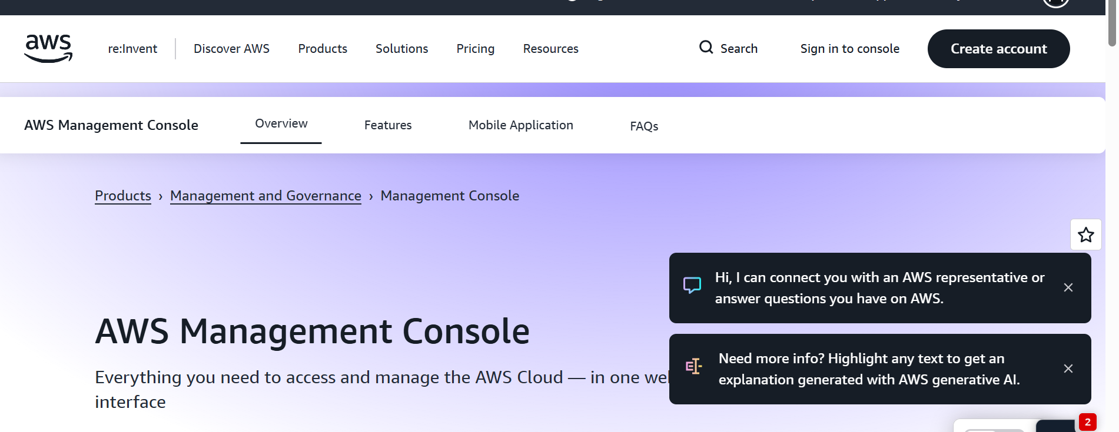

Here we have to select sign in to console then it will be asking for login credentials for login

Step 2: - Login in to Aws Account as a root user

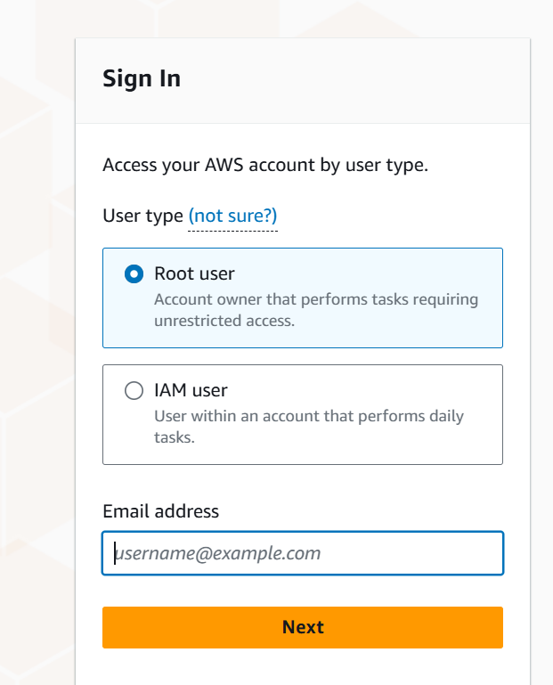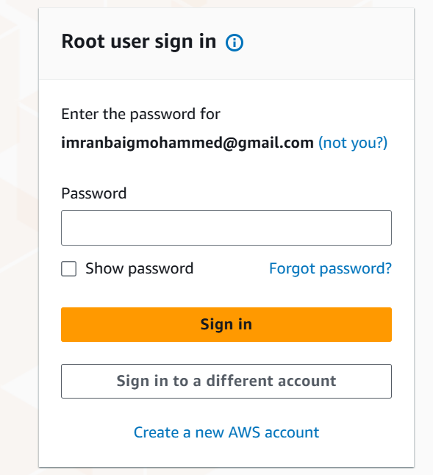

- Here we will sign in as a root user, the root user has all the access of the Aws account to work with any service available in Aws cloud

- Step 3: - IAM User creation for login into the Aws cloud

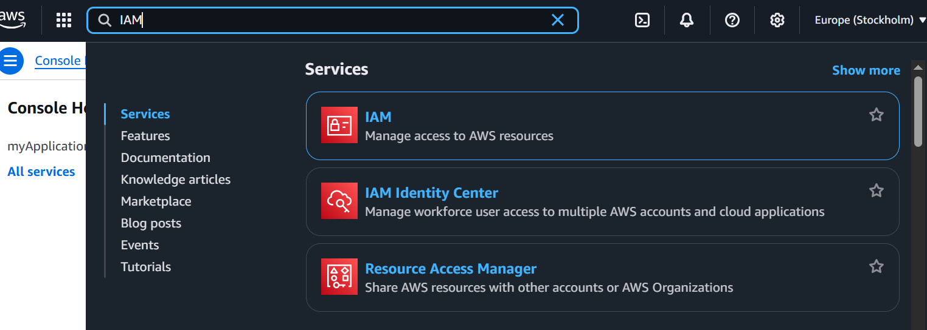

- After Login we will be able to see the Home Page there we can see all the services available
- Go to the search bar and search for IAM and Select IAM service

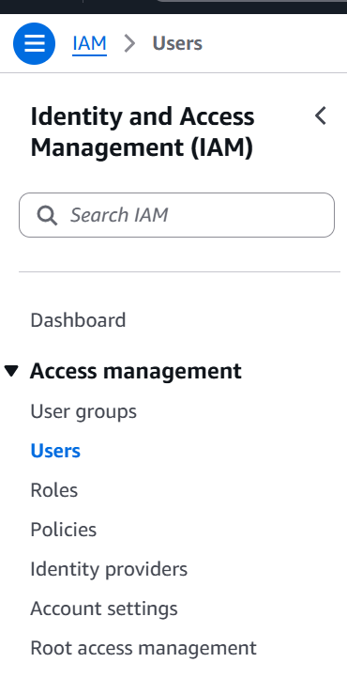
- Step 4: - User configuration for an IAM user

- In the IAM dashboard, look at the left-hand navigation panel and click on the 'Users' option. This section displays all existing IAM users and provides options for adding new ones.

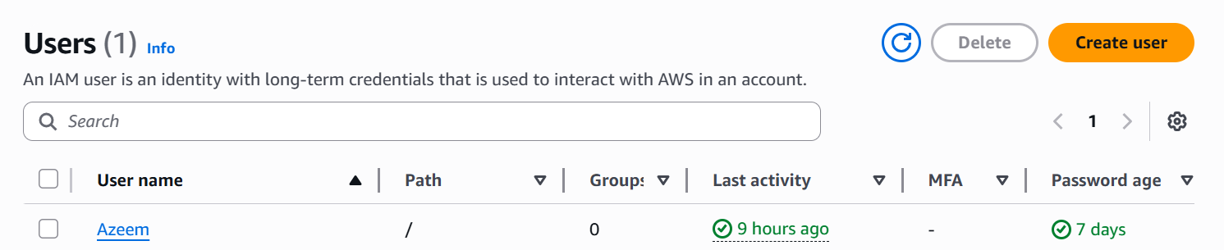

- Click the 'Create User' button to start the user creation process. This opens the user configuration of an IAM user.
- we can control the access given to the IAM user from the root user
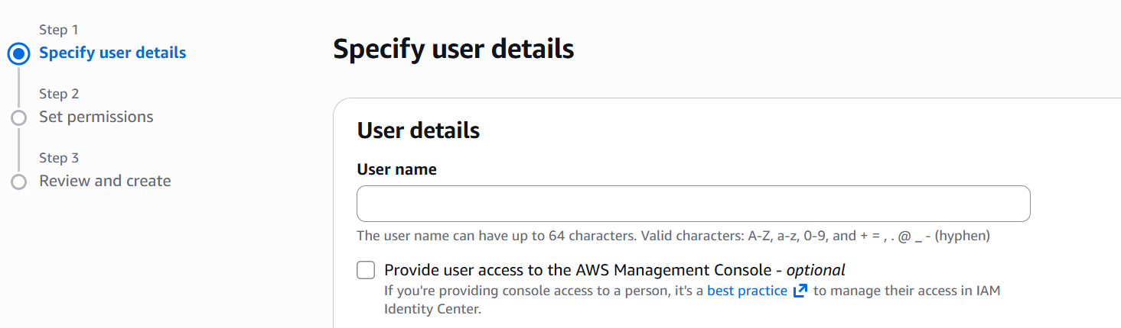
- Now we will be Specifying the User name for the IAM user so that we will be able to login with that User name as a IAM user
- We have to click on the check box to provide the AWS Management Console access

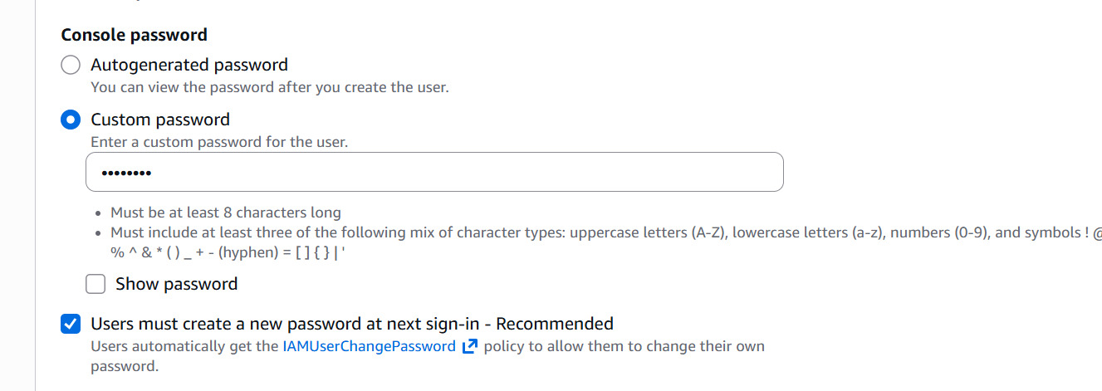

- Here we have to Give a 'Console Password' and either create a password manually or choose auto-generated. You can also require the user to reset the password on their first login.

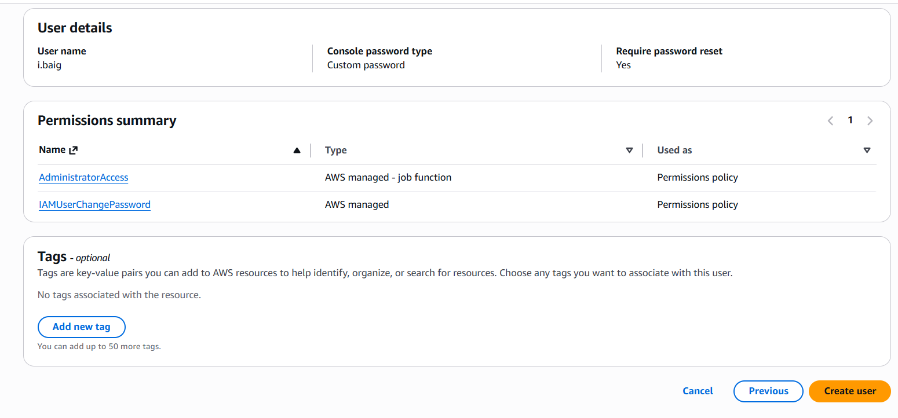

- Here we will give Administrator access so that IAM user can access all the services available in the AWS cloud and IAM user Change Password access, so that IAM user can change set their own password
- After giving the required permissions to the IAM user click on create user

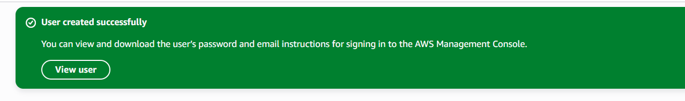
- Now our IAM user creation is completed
- Now we can login in to the AWS Console as a IAM user

- Step 5: - Sign in to AWS Console as IAM user and reset password for IAM user

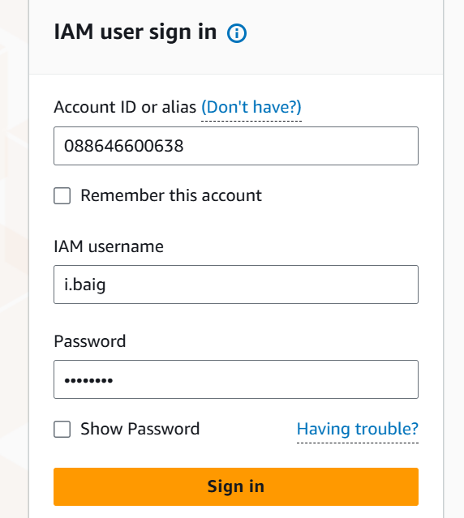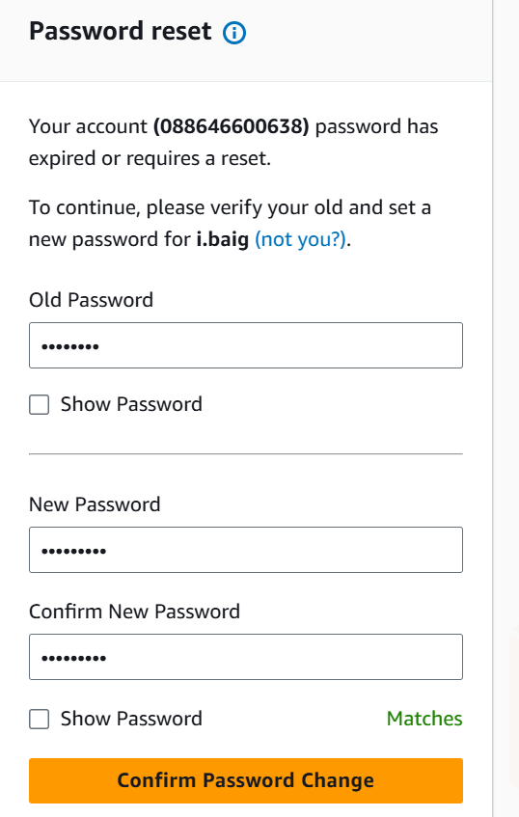

- Now we can sign in to the AWS Console as a IAM user and we have to reset the password given by the root user
- By resetting the password, the IAM user account will be safe and secure
- After the completion of resetting the password, we have to login by providing the required credentials

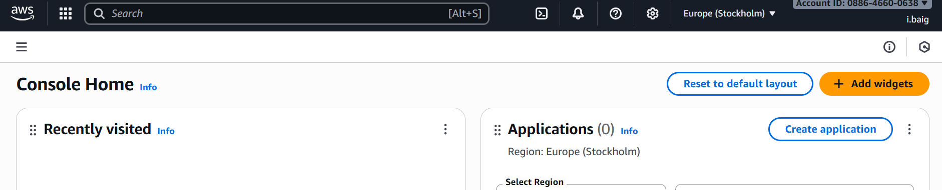

- Here we can see the Home screen after login in to the AWS Console as a IAM user

